FRIENDS AND FAMILY TEST
Results for January 2024

Thank you to all the patients who completed a friends and family test survey
in January 2024

- How likely are you to recommend our practice to family and friends if they needed similar care or treatment?
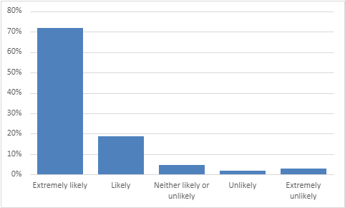
72% are extremely likely to recommend the practice.
45% are likely to recommend the practice.
11% are neither likely nor unlikely to recommend the practice.
5% are unlikely to recommend the practice.
7% are extremely unlikely to recommend the practice.

- If we could change one thing about your care or treatment, what would it be?
- Dr Brown is very good at his job and very knowledgeable and understanding. Dr Brown is superb.
- Special thanks to Dr Hart for prompt and thorough care. Dr Hart is an asset to the surgery.
- Dr Hart listened and was fantastic.
- Happy with Dr Rawson. He always listens and makes me feel confident in his care.
- Dr Harris is always willing to take the time to listen and discuss any concerns.
- Dr Harris is really helpful and polite.
- Nothing, Justine was fantastic with my daughter. Nurse was amazing, love her.
- Tracey is amazing to deal with. The HCA is very thorough and helpful.
- Excellent service. Sue behind the desk is so lovely.
- Sue on reception is wonderful. All staff are very polite and helpful. Very good back room staff.
- Always exceptional. The staff and doctors are always accommodating and caring.
- Everything was perfect, from booking the appointment to being seen.
- Nothing, I am amazed with the service. Totally satisfied.
- Nothing, you are all wonderful. Only had positive experiences to date.
- Service was awesome. Very happy with the service from all medical and support staff.
- I am looking forward to the new triage system. I hope it will benefit both staff and patients.
- I have just joined this practice and couldn’t be happier. Your practice is an improvement from Wigan.
- To be able to get face to face appointments and get appointments sooner. Continuity of care.
- Allow same day, first come first serve appointments. Have a drop in surgery with no appointments.
- To be able to get through on the telephone more easily.
- Staff not always friendly or helpful. Staff can sometimes be rude both on telephone and in surgery.
- Less technology and more personal communication. I cannot use technology.
- Don’t like the idea of the new booking system. My husband is blind so of no use to him.
- Not sure the new triage system suitable for older patients. Not everyone on the Internet.

